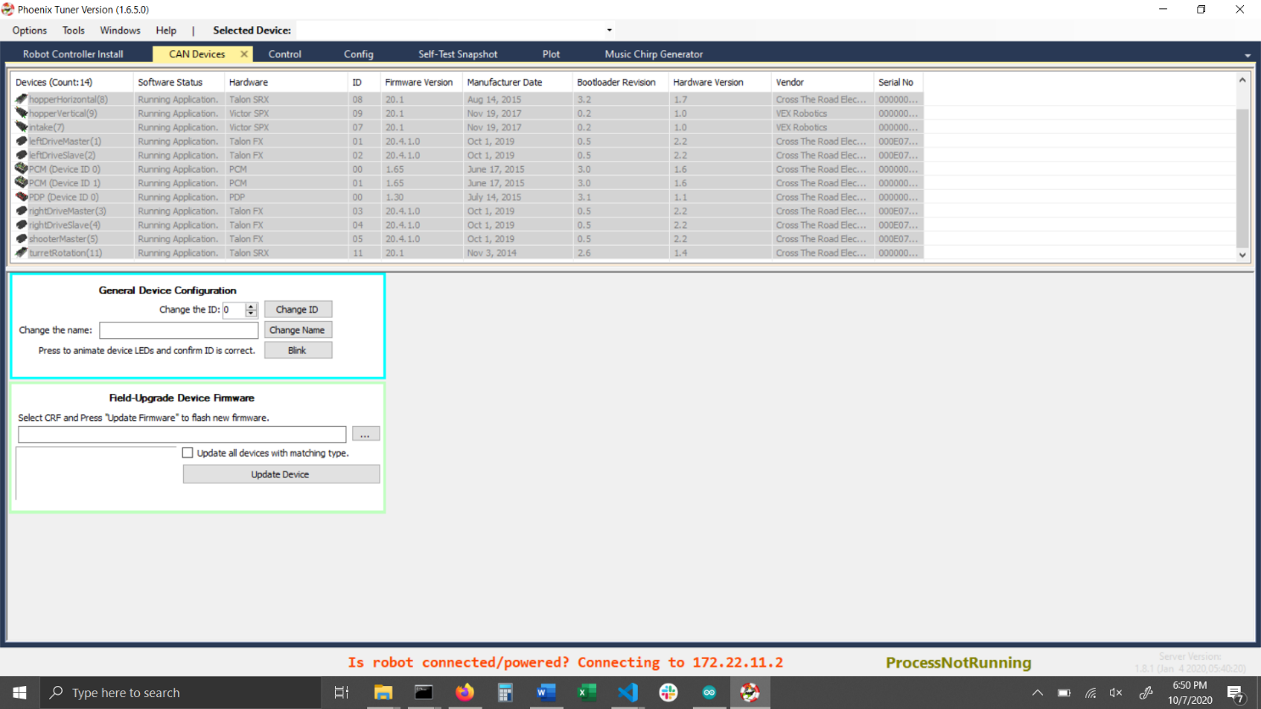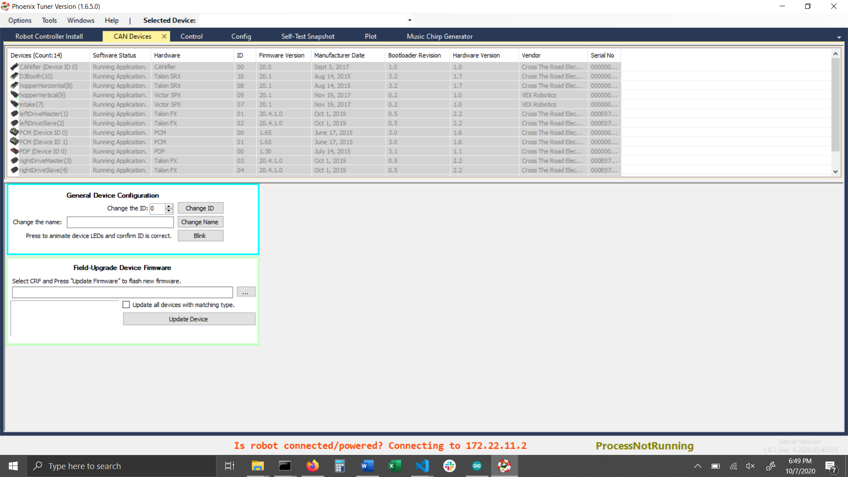

Auto shoot routine

* Auto align using speed / servo and rotate / turret
* Turn on shooter during align check and if checked fire, maybe toggle intakes

Limelight targeting w/ turret and chassis w/ PID

* Turret needs constant back pressure that needs to be toggled in the direction of the last move

Better chassis control (pos / vel/ gyro/ closed loop)

* Chassis rotation is crazy, combat w/ custom ramped inputs for precision control and gyro stabilization PID to prevent over turning
* Closed loop ramping based of velocity drive also w/ custom ramped input
* Lower turning ability slightly based on speed
* Find max velocity on drained battery

Climber / WOF

Sonar sensors

Controls and debugging

Automatic systems check

Determine total voltage drain, make more efficient (shooter constantly on)

Pixie cam

Turret Left Max:1600

Right: -1600

